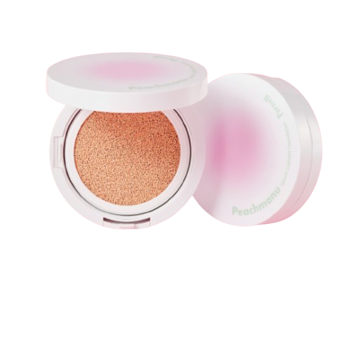
Name : Peach manu foundation
Description : A serum-infused cushion foundation that gives a dewy, natural glow. It provides light to medium coverage, keeps skin hydrated, and blends smoothly without feeling heavy. Enriched with peach, cica, and honey, plus SPF 50+ PA+++ for daily sun protection. Ideal for a fresh, natural look.
How to use :
Clean and moisturize your face.
Press the cushion puff lightly into the foundation.
Gently tap the puff onto your face (do not rub).
Start from the center and blend outward.
Build coverage by adding more if needed

